软件学院 机器学习 课程实验报告

实验题目：贝叶斯 |  | 学号：201700301166
日期：2019/10/21 | 班级： 网安17 |  | 姓名： 尹成林
Email：sdyinruichao@163.
实验软件和硬件环境：

编程语言：python3.7
使用到的库：numpy库等（没有使用sklearn库）
操作系统：win10
硬件配置：
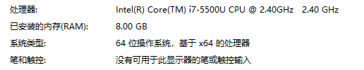

实验原理：
贝叶斯公式
最小分线贝叶斯分类器的公式等等
贝叶斯分类器编写的相关知识
Numpy的多维高斯分布产生
Numpy的统计计算
Random库的随机选择进行数据分类

实验方法、实验结果及实验结果分析：
编程中的相关函数具体的作用在代码中已写好注释，这里略过。

问题1求两种分类器，在这里我实现了之前选作题目的相关要求，可以输入均值，协方差矩阵生成数据并训练
问题2给出数据要求进行数据分类并测试性能。

问题1实验结果：
结果为1为正样本，结果为2为负样本
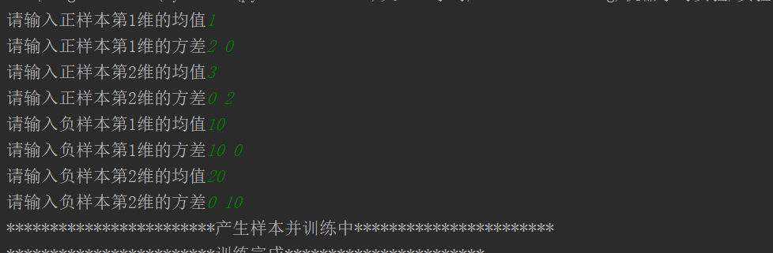
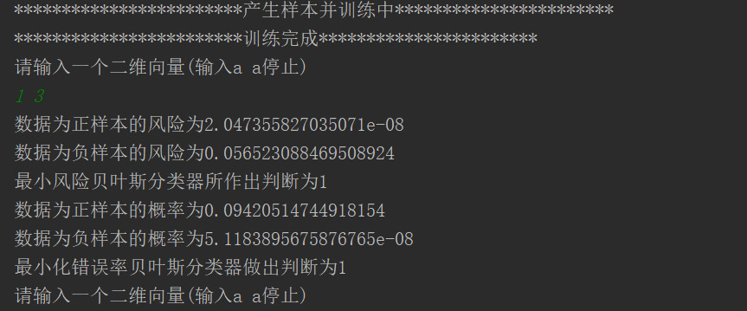
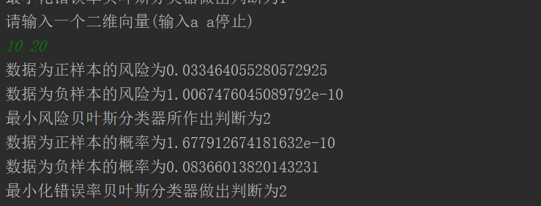
问题1实验方法：
- 了解两种不同贝叶斯分类器的区别：简单的来看，最小错误率贝叶斯分类器就是于朴素贝叶斯分类器，该怎么写就怎么写。
而最小风险贝叶斯分类器是基于朴素贝叶斯之上进一步的方法，首先会有权威认证的评估出来的错误风险，把错误风险与概率的乘积作为贴标签的标准，取其中风险最小的。
- 使用python的numpy库产生二维高斯分布正样本10000、负样本20000
- 使用产生的数据产生类条件概率分布函数
- 对数据进行分类
问题1 实验结果分析：
通过不同的概率比较，得出较大的可能性，皆为判断结果，因为实验数据随机产生且为高斯分布，好像也没有进行测试的必要，准确率推测应该较高。

问题二实验结果：
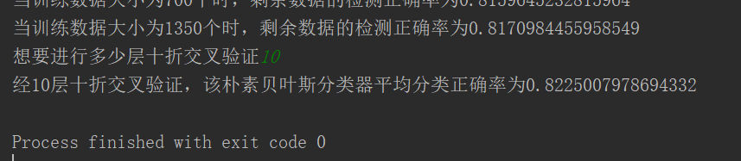

问题2实验方法：
- 了解贝叶斯分类器分类离散数据的原理：通过离散的类型进行统计，计算出相关的概率，先验后验概率等等等等
- 使用python的csv库导入数据
- 使用python的random库随机进行分组，分为十组以方便十折检验
- 编写相关函数

问题2 实验结果分析：
在刚做这道题的时候，我没有用十折测试，而是不断增加训练集的大小，发现随着训练集的增大，分类器的正确率也不断增大，这也符合我们的一贯认知。但同时，可能因为数据量在10^3也不是很大，尽管使用了十折，但每一次执行下来平均的正确率差异还是较大的，比较了多次甚至可能超过百分之2，于是为了避免这种情况，我设计进行了多次的十折测试，最后得出的结果在不同时间下运行得到的结果差异不大，我觉得满足的要求，于是就采取了这样的办法。

实验感悟与收获：
- 对课上所学的公式进行了实现，感受到了说与做之间的差别，以后要多多动手。
- 发现即使通过10折交叉验证，验证出来的结果也不是变化较小，于是我选择进行多重10折交叉验证，减少这样的误差
3.发现自己在听课过程中的一些不足，下一次上课我必坐第一排
实验代码：
第一问实验代码：

# 编写日期 2019/10/21
# 编写人 尹成林
# 学号 201700301166
# 实验 贝叶斯实验第1问
import numpy as np
from numpy.linalg import cholesky
import matplotlib.pyplot as plt
import math
# 定义数据
c = math.sqrt(2*math.pi)
posim = 10000
antisin = 20000
def makepodata(m1, m2, s1, s2, s3, s4):
sampleNo = posim;
mu = np.array([[m1, m2]])
Sigma = np.array([[s1, s2], [s3, s4]])
R = cholesky(Sigma)
s = np.dot(np.random.randn(sampleNo, 2), R) + mu
return s
def makeantidata(m1, m2, s1, s2, s3, s4):
sampleNo = antisin;
mu = np.array([[m1, m2]])
Sigma = np.array([[s1, s2], [s3, s4]])
R = cholesky(Sigma)
s = np.dot(np.random.randn(sampleNo, 2), R) + mu
return s
def getu(s):
h = np.mean(s, axis=0)
return h
def gets(s):
h = np.var(s, axis=0)
return h
# 计算先验概率
def getPxc (num, u, s):
p = (1/(c*math.sqrt(s)))*pow((math.e),(-(num-u)*(num-u)/(2*s)))
return p
# 计算后验概率
def getPcx(c,u1,u2,s1,s2,num1,num2):
p1 = getPxc(num1, u1, s1)
p2 = getPxc(num2, u2, s2)
if c == 1:
return (1/3)*p1
else:
return (2/3)*p2
# 最小错误率计算和返回判断
def getminfau(num1, num2, u, s):
p1 = getPcx(1, u[0], u[1], s[0], s[1], num1, num2)
p2 = getPcx(2, u[2], u[3], s[2], s[3], num1, num2)
print("数据为正样本的概率为{}".format(p1))
print("数据为负样本的概率为{}".format(p2))
if p1>p2:
return 1
else:
return 2
# 最小风险判断
def getminrisk(num1, num2, u, s, risk):
p1 = getPcx(1, u[0], u[1], s[0], s[1], num1, num2)*risk[0]
p2 = getPcx(2, u[2], u[3], s[2], s[3], num1, num2)*risk[1]
print("数据为正样本的风险为{}".format(p2))
print("数据为负样本的风险为{}".format(p1))
if p1>p2:
return 1
else:
return 2
if __name__ == "__main__":
u = []
s = []
for i in range(2):
for i1 in range(2):
if i==0:
uuu = input("请输入正样本第{}维的均值".format(i1+1))
u.append(int(uuu))
u1,u2 = input("请输入正样本第{}维的方差".format(i1 + 1)).split()
s.append(int(u1))
s.append(int(u2))
if i==1:
uuu = input("请输入负样本第{}维的均值".format(i1+1))
u.append(int(uuu))
u1, u2 = input("请输入负样本第{}维的方差".format(i1 + 1)).split()
s.append(int(u1))
s.append(int(u2))
risk = [0.6, 0.4]
print("************************产生样本并训练中***********************")
data1 = makepodata(
u[0], u[1], s[0], s[1], s[2], s[3]
)
data2 = makeantidata(
u[2], u[3], s[4], s[5], s[6], s[7]
)
U1 = getu(data1)
U2 = getu(data2)
S1 = gets(data1)
S2 = gets(data2)
print("************************训练完成***********************")
while 1:
a, b = input("请输入一个二维向量(输入a a停止)\n").split()
a = int(a)
b = int(b)
UUU = []
for i in U1:
UUU.append(i)
for i in U2:
UUU.append(i)
SSS = []
for i in S1:
SSS.append(i)
for i in S2:
SSS.append(i)
print("最小风险贝叶斯分类器所作出判断为{}".format(getminrisk(a, b, UUU, SSS, risk)))
print("最小化错误率贝叶斯分类器做出判断为{}".format(getminfau(a, b, UUU, SSS)))

第二问相关代码：
# 编写日期 2019/10/21
# 编写人 尹成林
# 学号 201700301166
# 实验 贝叶斯实验第2问
import csv
import random
import numpy as np
# import pandas
# 数据导入及分成两份
def loadcsv(name):
f = csv.reader(open(name,'r'))
dataset = list(f)
return dataset
def randDivision(dataset , trainSize):
copy = list(dataset)
train = []
while len(train)<trainSize:
index = random.randrange(len(copy))
train.append(copy.pop(index))
return [train, copy]
#初始化一些数据
data1 = [[0.0,0.0,0.0,0.0],[0.0,0.0,0.0,0.0],[0.0,0.0,0.0,0.0],[0.0,0.0,0.0],[0.0,0.0,0.0],[0.0,0.0,0.0]]
dataunacc = [[0.0,0.0,0.0,0.0],[0.0,0.0,0.0,0.0],[0.0,0.0,0.0,0.0],[0.0,0.0,0.0],[0.0,0.0,0.0],[0.0,0.0,0.0]]
dataacc = [[0.0,0.0,0.0,0.0],[0.0,0.0,0.0,0.0],[0.0,0.0,0.0,0.0],[0.0,0.0,0.0],[0.0,0.0,0.0],[0.0,0.0,0.0]]
datagood = [[0.0,0.0,0.0,0.0],[0.0,0.0,0.0,0.0],[0.0,0.0,0.0,0.0],[0.0,0.0,0.0],[0.0,0.0,0.0],[0.0,0.0,0.0]]
dataVgood = [[0.0,0.0,0.0,0.0],[0.0,0.0,0.0,0.0],[0.0,0.0,0.0,0.0],[0.0,0.0,0.0],[0.0,0.0,0.0],[0.0,0.0,0.0]]
datavip = [0,0,0,0]
# 统计函数，将具体个数的多少进行统计
'''
*****************************************
训练器部分
*****************************************
'''
def stat(dataset):
for i in dataset:
count = i[0]
maint = i[1]
door = i[2]
persons = i[3]
lug = i[4]
safty = i[5]
vip = i[6]
addcount(count, data1)
addmaint(maint, data1)
adddoor(door, data1)
addperson(persons, data1)
addlug(lug, data1)
addsafty(safty, data1)
if vip == 'unacc':
datavip[0] = datavip[0]+1
addcount(count, dataunacc)
addmaint(maint, dataunacc)
adddoor(door, dataunacc)
addperson(persons, dataunacc)
addlug(lug, dataunacc)
addsafty(safty, dataunacc)
elif vip == 'acc':
datavip[1] = datavip[1] + 1
addcount(count, dataacc)
addmaint(maint, dataacc)
adddoor(door, dataacc)
addperson(persons, dataacc)
addlug(lug, dataacc)
addsafty(safty, dataacc)
elif vip == 'good':
datavip[2] = datavip[2] + 1
addcount(count, datagood)
addmaint(maint, datagood)
adddoor(door, datagood)
addperson(persons, datagood)
addlug(lug, datagood)
addsafty(safty, datagood)
elif vip == 'vgood':
datavip[3] = datavip[3] + 1
addcount(count, dataVgood)
addmaint(maint, dataVgood)
adddoor(door, dataVgood)
addperson(persons, dataVgood)
addlug(lug, dataVgood)
addsafty(safty, dataVgood)
##上面函数的仔函数
def addcount(count,data):
if count == 'vhigh':
data[0][0] = data[0][0]+1
elif count == 'high':
data[0][1] = data[0][1]+1
elif count == 'med':
data[0][2] = data[0][2] + 1
elif count == 'low':
data[0][3] = data[0][3] + 1
def addmaint(maint,data):
if maint == 'vhigh':
data[1][0] = data[1][0]+1
elif maint == 'high':
data[1][1] = data[1][1] + 1
elif maint == 'med':
data[1][2] = data[1][2] + 1
elif maint == 'low':
data[1][3] = data[1][3] + 1
def adddoor(door,data):
if door == '2':
data[2][0] = data[2][0] + 1
elif door == '3':
data[2][1] = data[2][1] + 1
elif door == '4':
data[2][2] = data[2][2] + 1
elif door == '5more':
data[2][3] = data[2][3] + 1
def addperson(persons,data):
if persons == '2':
data[3][0] = data[3][0] + 1
elif persons == '4':
data[3][1] = data[3][1] + 1
elif persons == 'more':
data[3][2] = data[3][2] + 1
def addlug(lug,data):
if lug == 'small':
data[4][0] = data[4][0] + 1
elif lug == 'med':
data[4][1] = data[4][1] + 1
elif lug == 'big':
data[4][2] = data[4][2] + 1
def addsafty(safty,data):
if safty == 'low':
data[5][0] = data[5][0] + 1
elif safty == 'med':
data[5][1] = data[5][1] + 1
elif safty == 'high':
data[5][2] = data[5][2] + 1
# 将具体的个数转化为概率
def getP(num, data):
for k in range(len(data)):
for ii in range(len(data[k])):
data[k][ii] = data[k][ii]/num
'''
*****************************************
测试部分
*****************************************
'''
# 以下的函数为概率返回函数，再检验时起到查表的作用
def getR0(data, t):
if t == 'vhigh':
return data[0][0]
elif t == 'high':
return data[0][1]
elif t == 'med':
return data[0][2]
elif t == 'low':
return data[0][3]
def getR1(data, maint):
if maint == 'vhigh':
return data[1][0]
elif maint == 'high':
return data[1][1]
elif maint == 'med':
return data[1][2]
elif maint == 'low':
return data[1][3]
return 0
def getR2(data, door):
if door == '2':
return data[2][0]
elif door == '3':
return data[2][1]
elif door == '4':
return data[2][2]
elif door == '5more':
return data[2][3]
def getR3(data, persons):
if persons == '2':
return data[3][0]
elif persons == '4':
return data[3][1]
elif persons == 'more':
return data[3][2]
def getR4(data, lug):
if lug == 'small':
return data[4][0]
elif lug == 'med':
return data[4][1]
elif lug == 'big':
return data[4][2]
def getR5(data, safty):
if safty == 'low':
return data[5][0]
elif safty == 'med':
return data[5][1]
elif safty == 'high':
return data[5][2]
def getR6(num):
if num == 0:
return "unacc"
if num == 1:
return "acc"
if num == 2:
return "good"
if num == 3:
return "vgood"
rate = [0,0]
# 检验函数
def test(testset):
for line in testset:
rate0 = datavip[0]*getR0(dataunacc,line[0])*getR1(dataunacc,line[1])*getR2(dataunacc,line[2])*getR3(dataunacc,line[3])*getR4(dataunacc,line[4])*getR5(dataunacc,line[5])
rate1 = datavip[1]*getR0(dataacc,line[0])*getR1(dataacc,line[1])*getR2(dataacc,line[2])*getR3(dataacc,line[3])*getR4(dataacc,line[4])*getR5(dataacc,line[5])
rate2 = datavip[2]*getR0(datagood,line[0])*getR1(datagood,line[1])*getR2(datagood,line[2])*getR3(datagood,line[3])*getR4(datagood,line[4])*getR5(datagood,line[5])
rate3 = datavip[3]*getR0(dataVgood,line[0])*getR1(dataVgood,line[1])*getR2(dataVgood,line[2])*getR3(dataVgood,line[3])*getR4(dataVgood,line[4])*getR5(dataVgood,line[5])
k = getbig(rate0,rate1,rate2,rate3)
if line[6] != getR6(k):
rate[0] = rate[0]+1
else:
rate[1] = rate[1]+1
'''
*****************************************
总控函数和一些轮子函数
*****************************************
'''
##返回四个数中的最大值的下表
def getbig(r1,r2,r3,r4):
k = max(r1, r2, r3, r4)
if k == r1:
return 0
if k == r2:
return 1
if k == r3:
return 2
if k == r4:
return 3
# 初始化函数，初始化数组中的值
def renum():
data1 = [[0.0, 0.0, 0.0, 0.0], [0.0, 0.0, 0.0, 0.0], [0.0, 0.0, 0.0, 0.0], [0.0, 0.0, 0.0], [0.0, 0.0, 0.0],
[0.0, 0.0, 0.0]]
dataunacc = [[0.0, 0.0, 0.0, 0.0], [0.0, 0.0, 0.0, 0.0], [0.0, 0.0, 0.0, 0.0], [0.0, 0.0, 0.0], [0.0, 0.0, 0.0],
[0.0, 0.0, 0.0]]
dataacc = [[0.0, 0.0, 0.0, 0.0], [0.0, 0.0, 0.0, 0.0], [0.0, 0.0, 0.0, 0.0], [0.0, 0.0, 0.0], [0.0, 0.0, 0.0],
[0.0, 0.0, 0.0]]
datagood = [[0.0, 0.0, 0.0, 0.0], [0.0, 0.0, 0.0, 0.0], [0.0, 0.0, 0.0, 0.0], [0.0, 0.0, 0.0], [0.0, 0.0, 0.0],
[0.0, 0.0, 0.0]]
dataVgood = [[0.0, 0.0, 0.0, 0.0], [0.0, 0.0, 0.0, 0.0], [0.0, 0.0, 0.0, 0.0], [0.0, 0.0, 0.0], [0.0, 0.0, 0.0],
[0.0, 0.0, 0.0]]
datavip = [0, 0, 0, 0]
##总函数，调用上面的所有函数
def training(size):
renum()
trainSet, testSet = randDivision(dataset, size)
stat(trainSet)
getP(datavip[0], dataunacc)
getP(datavip[1], dataacc)
getP(datavip[2], datagood)
getP(datavip[3], dataVgood)
test(testSet)
Rate = rate[1] / (rate[0] + rate[1])
print("当训练数据大小为{0}个时，剩余数据的检测正确率为{1}".format(size, Rate))
# 返回合并后的训练集
def getTrainTest(kkk, datas):
kkkk = 0
traindata = []
for i in datas:
if kkkk == kkk:
continue
kkkk = kkkk+1
traindata = traindata + i
return traindata
# 求平均值函数
# 十折交叉验证函数
def TenFordCV(size,nums):
renum()
s = int(size/nums)
dataForTfcv = []
kkk = 0
Rate = []
testSet = dataset
for i in range(nums-1):
trainSet, testSet = randDivision(testSet, s)
dataForTfcv.append(trainSet)
dataForTfcv.append(testSet)
for i in dataForTfcv:
renum()
testSetForTen = getTrainTest(kkk, dataForTfcv)
kkk = kkk+1
stat(testSetForTen)
getP(datavip[0], dataunacc)
getP(datavip[1], dataacc)
getP(datavip[2], datagood)
getP(datavip[3], dataVgood)
test(i)
Rate.append(rate[1] / (rate[0] + rate[1]))
#print("第{}次正确率为{}".format(kkk,rate[1] / (rate[0] + rate[1])))
return np.mean(Rate)
if __name__=="__main__":
name = "..\..\data\car.csv"
dataset = loadcsv(name)
training(100)
training(200)
training(500)
training(700)
training(1350)
ppp = input("想要进行多少层十折交叉验证")
r = []
for i in range(int(ppp)):
r.append(TenFordCV(1728, 10))
print("经{}层十折交叉验证，该朴素贝叶斯分类器平均分类正确率为{}".format(ppp, np.mean(r)))

